Born to be Somebody
By: Lexus Kerr

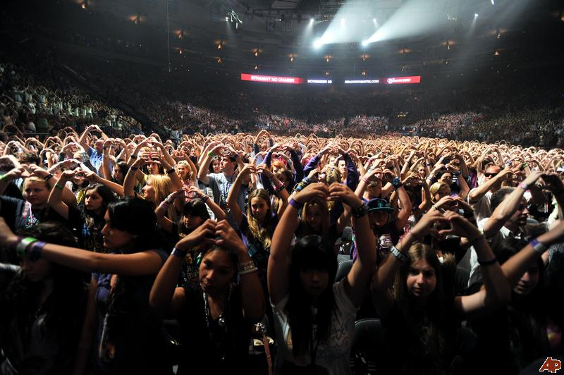
Inspiring.
He’s had a love for music since the age of three.
He’s came so far in his life.
Billions of albums sold.
Countless awards.
Millions of fans.
Most hits on Youtube.
May I remind you, he’s only nineteen years old.

Bieber Fever us girls call it.
It’s that feeling you get,
Watching your idol live his dream.
He’s a heartthrob sensation.
Stealing the hearts of young girls all around the world.
May I remind you, he’s only nineteen years old.

Underdog.
Discovered by Scooter Braun at the age of twelve.
He worked his way to the top.
Numerous tours, sleepless nights, and days in the studio—
He does it all.
May I remind you, he’s only nineteen years old.

Justin Drew Bieber—from a small town in Canada.
He may pee in mop buckets,
Spit on his fans,
Have a lot of tattoos,
And wrestle with love,
But he’s only nineteen years old.

Learning.
Learning from his mistakes.
He’s becoming a better man—a better person.
His career is far from over,
And he will continue to impress others
Because he’s only nineteen years old.

