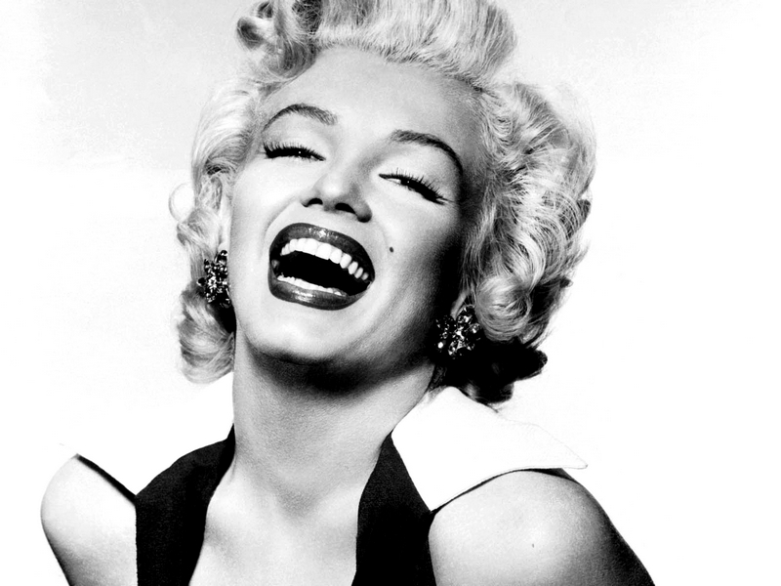
W E E K L Y
iNTOUCH

Mairlyn Monroe
“I don’t want
to make money,
I just want
to be wonderful.”
GET THE
SECRET TO
BETTER HAIR

MONROE’S
STYLE
Pg. 6

